**Amazon Pantry**

**Project Task on Business Analysis**

Q1) Identifying Stakeholders – Create a list of Stakeholders (as taught in Business Analysis Planning and Monitoring Knowledge Area)

Ans) The list of the Stakeholders of the Amazon Pantry are as follows:

1. **ABC customers:** responsible for searching the daily essential items from theAmazon Pantry for shopping. Some of the categories of the daily essential items for shopping are Flour and Rice,Sugar,salt and spices,Pulses,Personal Care,Snacks,Hand Wash and Sanitizers,Household cleaning essentials, Breakfast food items,Tea and Coffee,Baby Care,Female Hygiene and Tissue and Fresheners
2. **ABC Pantry Delivery Boy:** responsible for free delivery from the Amazon Pantry only if the total order exceeds 50 USD
3. **ABC Management:** responsible for viewing the reports from Amazon Pantry software at the end of the day

Q2) Create As-Is and Future Process map (using flowcharts). You can use any of the popular tools in the market like Microsoft Visio, Lucid Chart, Creately, Pidoco, or Balsamiq

Ans) The flowchart of the existing ABC Company’s App or Website is as follows:

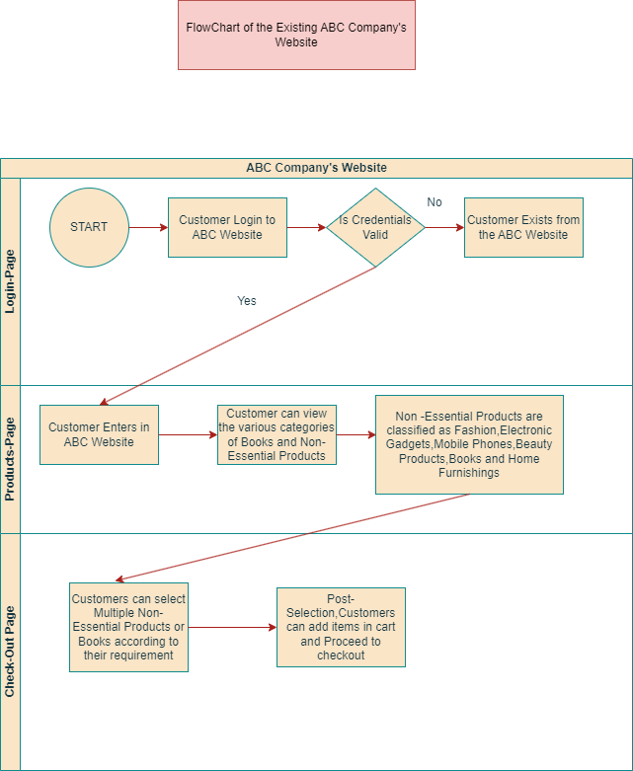

The above mentioned is as-is Process Map of existing ABC Company’s Website

The below mentioned is the Future Process Map of ABC Company’s Website along with ABC Pantry

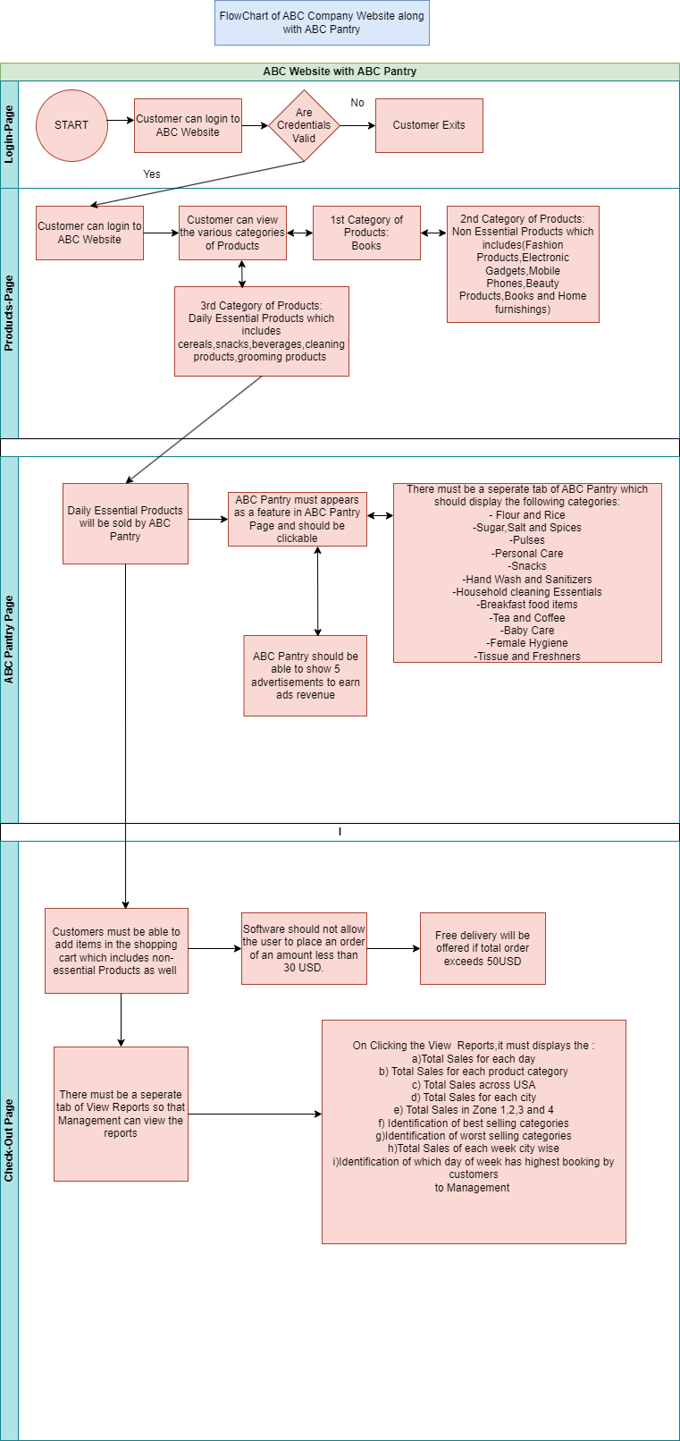

Q3) As a Business Analyst working on this project, find out the scope of the feature ABC Pantry. Write down the main features that need to be developed.

Ans) Scope of the feature ABC Pantry are the boundaries of the ABC Pantry. Some of the **in-scope** ABC pantry features are as follows:

1. ABC pantry would sell daily essential products like cereals,snacks,beverages,cleaning products,grooming products and so on
2. ABC pantry is one of the sub-feature of the ABC website

The main features that **need to be developed in ABC Pantry are as follows**:

1. ABC Company’s website must have a separate feature of ABC Pantry
2. There must be a separate tab of ABC Pantry inside the ABC website which is clickable and should display the new range and various categories of Products
3. ABC Pantry feature must be clearly visible in both website and app
4. When the user clicks on the ABC Pantry,it must display the various daily essential items categories of Flour and Rice,Sugar,Salt and Spices,Pulses,Personal Care,Snacks,Hand Wash and Sanitizers,Household Cleaning Essentials,Breakfast Food Items,Tea and Coffee,Baby Care,Female Hygiene as well as Tissue and Fresheners
5. ABC Pantry should be able to show five advertisments to earn the advertising revenue
6. The software should not allow the user to place an order of amount less than 30USD
7. Free delivery will be offered if the total order exceeds 50USD
8. There must be a separate section or tab of viewing reports which displays the following information to the Management:

-Total sales for each day

-Total sales for each product category

-Total sales across USA

-Total sales for each city

-Total sales in zone 1,2,3 and 4

-Identification of best selling categories

-Identification of worst selling categories

-Total sales of each week city wise

- Identification of which day of week shows highest booking by customers

Q4) Write the in-scope and out-of-scope items for this software.

Ans) **In-scope requirements** of the software are the requirements which lie inside the boundary

While **out-scope requirements** are those which lie outside the boundary of the software.

Some of the **In-scope requirements** of the software are as follows:

1. ABC Company’s website must contains the feature of ABC Pantry for selling daily essential products
2. Inside the web page of ABC Website, there should be one menu page for displaying the books,non-essential products and Daily Essential Products
3. The non-essential products in ABC Website must be classified as fashion,electronic gadgets,mobile phones,beauty products,books and home furnishings
4. The daily essential products in ABC Website must be classified as Flour and Rice,Sugar,Salt and Spices,Pulses,Personal Care,Snacks,Hand Wash and Sanitizers,Household cleaning essentials,Breakfast food items,Tea and Coffee,Baby Care,Female Hygiene as well as Tissues and Fresheners
5. The ABC Pantry should be able to show five advertisements to earn the advertising revenues.
6. Only the Management of the ABC Company can view the reports at the end of the day. The reports must contain the information of Total Sales for each day, Total sales for each product category, Total Sales Across USA, Total Sales for each city, Total Sales in zone 1,2,3 and 4,Identification of best selling categories, Identification of worst selling categories, Total Sales of each week city wise and identification of day of the week which shows highest booking by the customers

Some of the **out-of-scope items** for this software are as follows:

1. If the view reports section is visible to any alternate Management except ABC Management,then it comes under out of scope requirement
2. If the ABC pantry software is displaying more than five advertisments,then it also comes under out of scope requirement
3. The ABC Pantry software allowing the user to place an order of an amount less than 30 USD is also one of the out of scope requirement
4. If the software is allowing free delivery for the total orders less than equal to 50 USD is also a part of out-of scope requirement
5. The ABC Pantry software presence in any alternate city except Chicago,New York,Seattle,Washington,Kanas City,San Jose,Dallas,Miami,New Orleans,Phoenix,Jersey City and Madison comes under Out-of scope requirement

Q5) Write out the business requirements, both functional and non-functional Requirements

Ans) **Functional Requirements:** are the requirements which must be present in the product.These are the functions which developer must enable to accomplish their tasks

Some of the functional requirements of automated ABC software are as follows:

1. The Web Page of ABC software must have a new feature of ABC Pantry
2. This ABC Pantry tab or section must be clickable and would open a new range and categories of product
3. The ABC Pantry feature should be visible in both website and app
4. When the user clicks on the ABC Pantry,it must display the logical grouping of products for each customers.
5. While clicking on ABC Pantry,entire list of daily essential items must be visible in front of user.
6. The categories which are present in the daily essential items are Flour and rice,Sugar,Salt and Spices,Pulses,Personal care,Snacks,Hand Wash and Sanitizers,Household cleaning essentials,Breakfast food items,Tea and Coffee,Baby Care,Female Hygiene and Tissue and Fresheners
7. When the user clicks on ABC Pantry,a detailed drop down must appears in front of the customers/users. The first drop down should be able to show the five advertisements while the second drop down shows the certain offers that are created for customers
8. The software should not allow the user to place an order of amount less than 30USD.Individual items can be added in the shopping cart which are less than 30USD,but the total price has to exceed 30USD
9. There must be a provision of Free delivery in the software for the orders which exceeds 50USD
10. Their must be a separate section of tab of viewing reports in the ABC Pantry Software which is clickable. When the Management of ABC Software clicks on the reports tab, a detailed format of following reports which contains the Total Sales for each day,Total Sales for each product,Total Sales across USA,Total sales for each city,Total sales for zones 1,2,3 and 4,identification of best selling categories,identification of worst selling categories,Total sales for each city and identification of day of week showing highest booking by customers should be visible to the Management of ABC Software

**Non-Functional Requirements-**: are the quality of the system.These are the quality attributes.They are the support features. Some of the Non-Functional Requirements of the software are as follows:

1. **Availability:** The ABC automated software must be available for various customers of Chicago,New York,Washington,Seattle,Kanas City,San Jose,Dallas,Miami,New Orleans,Phoenix,Jersey City and Madison
2. **Compatibility**: The software must handle the registrations of various customers of Chicago,New York,Seattle,Washington,Kanas City,San Jose,Dallas,Miami,New Orleans,Phoenix,Jersey City and Madison
3. **Usability**: The software is easy to use for natives of above mentioned cities
4. **Security:** The automated ABC Software along with ABC Pantry can handle threat,viruses and malicious attacks
5. **Localization:** The UI(user-interface) of the software is designed in English Language and the price of items are mentioned in USD
6. **Extensibility**: The software can incorporate new features according to Stakeholder requirements
7. **Compliance**: Only the citizens of Chicago,New York,Seattle,Washington,Kanas City,San Jose,Dallas,Miami,New Orleans,Phoenix,Jersey City,Madison and the Management of ABC software can access the software. No other outsider apart from the above mentioned cities can access the software as it will ask for credentials
8. **Portability:** Only the citizens or natives of the above mentioned cities can access the automated software on every desks.It must be portable and handy

Q6) Draw wireframes or mock screens for any two of the features. Use the technique prototyping or wireframing that is taught in the training. You can use any of the wireframing tools like Microsoft PowerPoint, Microsoft Word, Balsamiq, Sketch, Adobe XD, Adobe ILLustrator, Figma, UXPin, InVision Studio, Invision Freehand, or Moqups.

Ans) The wireframe of Daily Essential Items of Automated ABC Website along with ABC Pantry is as follows:

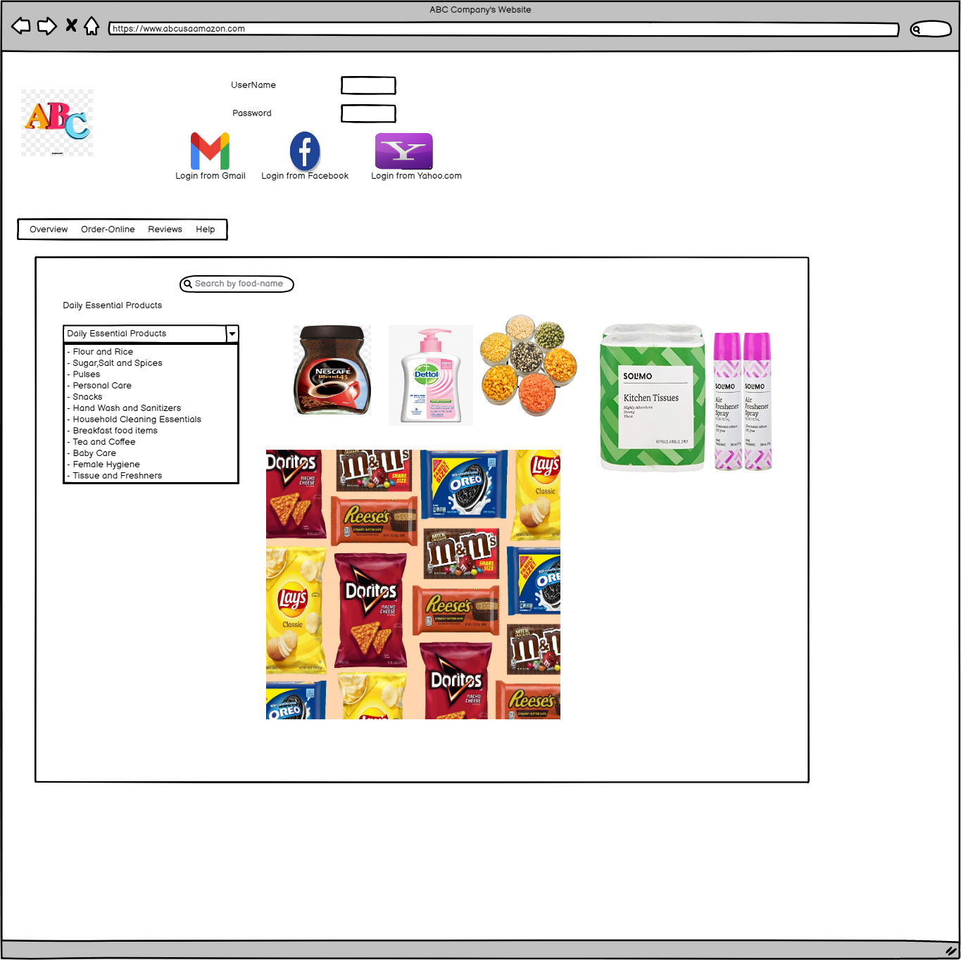

The wireframe of Order details of ABC Website with ABC Pantry is as follows:

